COURSE: CSA1715-Artificial Intelligence Name: Santhosh Kumar L
DATE: 23.07.2026 Reg.no: 192565076

EXPERIMENT 4: Write a Python Program for Crypt-Arithmetic Problem
Aim
To write a Python program to solve a Crypt-Arithmetic problem by assigning unique digits to letters and finding a valid solution that satisfies the given arithmetic equation automatically.

Algorithm
Step 1: Start the program.
Step 2: Read the first word, second word, and result word from the user.
Step 3: Identify all the unique letters present in the three words.
Step 4: Check whether the number of unique letters is greater than 10. If yes, display that no solution is possible.
Step 5: Generate all possible digit combinations for the unique letters using permutations.
Step 6: Assign one unique digit to each letter.
Step 7: Ensure that the first letter of each word is not assigned the digit zero.
Step 8: Convert the words into numbers using the assigned digits.
Step 9: Check whether the sum of the first two numbers is equal to the result number.
Step 10: Display the letter-to-digit assignments and the solution if the condition is satisfied; otherwise, continue checking other combinations.
Step 11: Stop the program.

Program
from itertools import permutations

# Digits from 0 to 9
digits = range(10)

# Generate all possible digit arrangements
for p in permutations(digits, 8):

S, E, N, D, M, O, R, Y = p

# First digit of a number cannot be zero
if S == 0 or M == 0:
continue

# Form the numbers
SEND = 1000 * S + 100 * E + 10 * N + D
MORE = 1000 * M + 100 * O + 10 * R + E
MONEY = 10000 * M + 1000 * O + 100 * N + 10 * E + Y

# Check the Crypt-Arithmetic condition
if SEND + MORE == MONEY:

print("Solution Found!")
print("-------------------------")

print("S =", S)
print("E =", E)
print("N =", N)
print("D =", D)
print("M =", M)
print("O =", O)
print("R =", R)
print("Y =", Y)

print("\nCalculation:")
print(" ", SEND)
print("+ ", MORE)
print("-------")
print(" ", MONEY)

break
else:
print("No solution exists.")

Output
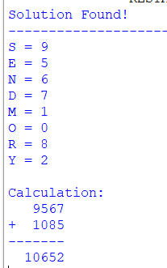

Result
The Python program successfully solves the Crypt-Arithmetic problem by assigning unique digits to letters and displays the correct letter-to-digit mapping that satisfies the given arithmetic equation.

EXPERIMENT 5: Write a Python Program for Missionaries and Cannibals Problem
Aim
To write a Python program to solve the Missionaries and Cannibals problem by finding a safe sequence of moves. To ensure that the missionaries are never outnumbered by cannibals on either side of the river.
Algorithm
Step 1: Start the program.
Step 2: Initialize the number of missionaries and cannibals on the left side of the river.
Step 3: Define the safe sequence of boat movements.
Step 4: Display the initial state of missionaries, cannibals, and boat position.
Step 5: Move the boat according to the predefined solution.
Step 6: After each move, display the updated number of missionaries, cannibals, and boat position.
Step 7: Repeat the process until all missionaries and cannibals reach the right side safely.
Step 8: Stop the program.
Program
from collections import deque

def is_valid(m_left, c_left):
m_right = 3 - m_left
c_right = 3 - c_left

if m_left < 0 or c_left < 0 or m_left > 3 or c_left > 3:
return False

if m_left > 0 and m_left < c_left:
return False

if m_right > 0 and m_right < c_right:
return False

return True

def solve():
start = (3, 3, 0)
goal = (0, 0, 1)

moves = [(1,0), (2,0), (0,1), (0,2), (1,1)]

queue = deque()
queue.append((start, [start]))
visited = set()

while queue:
state, path = queue.popleft()

if state == goal:
print("Solution Found:\n")
for step in path:
m, c, b = step
side = "Left" if b == 0 else "Right"
print("Missionaries:", m,
"Cannibals:", c,
"Boat:", side)
return

if state in visited:
continue

visited.add(state)

m, c, b = state

for dm, dc in moves:
if b == 0:
new_state = (m - dm, c - dc, 1)
else:
new_state = (m + dm, c + dc, 0)

if is_valid(new_state[0], new_state[1]) and new_state not in visited:
queue.append((new_state, path + [new_state]))

print("No Solution Found.")

solve()
Output:
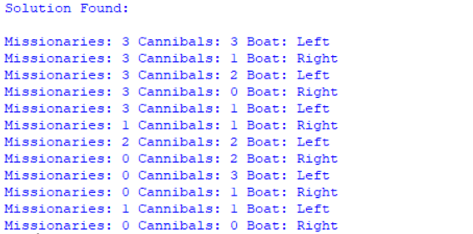

Result
Thus, the Missionaries and Cannibals problem was successfully solved using the Breadth-First Search algorithm, and all three missionaries and three cannibals were safely moved from the left bank to the right bank.

EXPERIMENT 6: Write a Python Program for Vacuum Cleaner Problem
Aim
To implement the Vacuum Cleaner problem using a simple reflex agent that cleans two rooms based on their current condition.
Algorithm
Step 1: Start the program.
Step 2: Read the status of Room A and Room B (Clean or Dirty).
Step 3: Read the initial position of the vacuum cleaner (A or B).
Step 4: Check the current room. If it is dirty, clean the room.
Step 5: Move the vacuum cleaner to the other room.
Step 6: Check the status of the second room. If it is dirty, clean the room.
Step 7: Display the final status of both rooms.
Step 8: Stop the program.

Program
room = {
"A": input("Enter status of Room A (Clean/Dirty): "),
"B": input("Enter status of Room B (Clean/Dirty): ")
}

position = input("Enter Vacuum Position (A/B): ").upper()

print("\nInitial Room Status")
print(room)

if position == "A":
if room["A"] == "Dirty":
print("Cleaning Room A")
room["A"] = "Clean"

print("Moving to Room B")

if room["B"] == "Dirty":
print("Cleaning Room B")
room["B"] = "Clean"

elif position == "B":
if room["B"] == "Dirty":
print("Cleaning Room B")
room["B"] = "Clean"

print("Moving to Room A")

if room["A"] == "Dirty":
print("Cleaning Room A")
room["A"] = "Clean"

print("\nFinal Room Status")
print(room)
Sample Input
Enter vacuum Position (A/B): A
Enter condition of Room A (Clean/Dirty): Dirty
Enter condition of Room B (Clean/Dirty): Dirty

Output
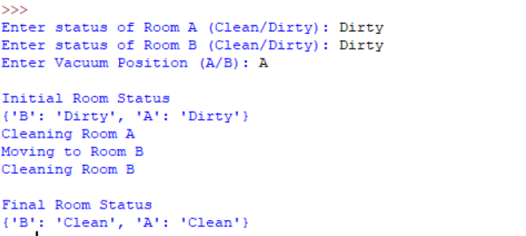

Result
Thus, the Vacuum Cleaner problem was successfully implemented using a simple reflex agent, and both Room A and Room B were cleaned successfully.

EXPERIMENT 7: Write a Python Program for Breadth-First Search
Aim
To write a Python program to implement the Breadth-First Search (BFS) algorithm for graph traversal and visit all the nodes level by level starting from the given source node.
Algorithm
Step 1: Start the program.
Step 2: Create the graph using an adjacency list.
Step 3: Read the starting node from the user.
Step 4: Initialize an empty visited list and a queue.
Step 5: Add the starting node to both the visited list and the queue.
Step 6: Remove the first node from the queue and display it.
Step 7: Visit all unvisited neighboring nodes, mark them as visited, and add them to the queue.
Step 8: Repeat Steps 6 and 7 until the queue becomes empty.
Step 9: Stop the program.

Program
from collections import deque

graph = {
'A': ['B', 'C'],
'B': ['D', 'E'],
'C': ['F'],
'D': [],
'E': ['F'],
'F': []
}

start = input("Enter starting node: ").upper()

visited = []
queue = deque()

visited.append(start)
queue.append(start)

print("BFS Traversal:")

while queue:
node = queue.popleft()
print(node, end=" ")

for neighbour in graph[node]:
if neighbour not in visited:
visited.append(neighbour)
queue.append(neighbour)
Sample Input
Enter starting node: A
Output
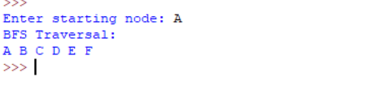

Result
The Python program successfully performs Breadth-First Search (BFS) traversal by visiting all the nodes level by level from the given starting node and displays the traversal order correctly.

EXPERIMENT 8: Write a Python Program for Depth-First Search
Aim
To implement the Depth-First Search algorithm in Python and traverse all the vertices of a graph by exploring one path completely before moving to another path.
Algorithm
Step 1: Start the program.
Step 2: Create the graph using an adjacency list.
Step 3: Read the starting node from the user.
Step 4: Initialize an empty visited list.
Step 5: Visit the starting node and mark it as visited.
Step 6: Display the current node.
Step 7: Recursively visit each unvisited adjacent node until no unvisited neighbors remain.
Step 8: Continue the process until all reachable vertices have been visited.
Step 9: Stop the program.
Program
# Depth-First Search function
def dfs(graph, vertex, visited):
visited.add(vertex)
print(vertex, end=" ")

for neighbor in graph[vertex]:
if neighbor not in visited:
dfs(graph, neighbor, visited)

# ---------------- MAIN PROGRAM ----------------

graph = {}

vertices = int(input("Enter the number of vertices: "))

# Create an empty adjacency list
for i in range(vertices):
graph[i] = []

edges = int(input("Enter the number of edges: "))

print("Enter the edges:")

for i in range(edges):
u, v = map(int, input().split())

# Undirected graph
graph[u].append(v)
graph[v].append(u)

start = int(input("Enter the starting vertex: "))

# Validate the starting vertex
if start not in graph:
print("Invalid starting vertex.")
else:
visited = set()

print("\nDFS Traversal:")
dfs(graph, start, visited)

Sample Input
Enter the number of vertices: 6
Enter the number of edges: 6

Enter the edges:
0 1
0 2
1 3
1 4
2 5
4 5

Enter the starting vertex: 0

Output
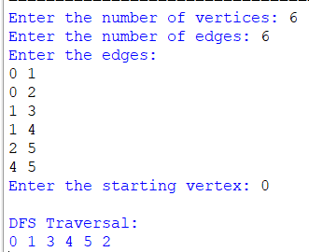
Result
Thus, the Depth-First Search algorithm was successfully implemented in Python, and all the reachable vertices of the graph were traversed by exploring each path deeply before backtracking.

